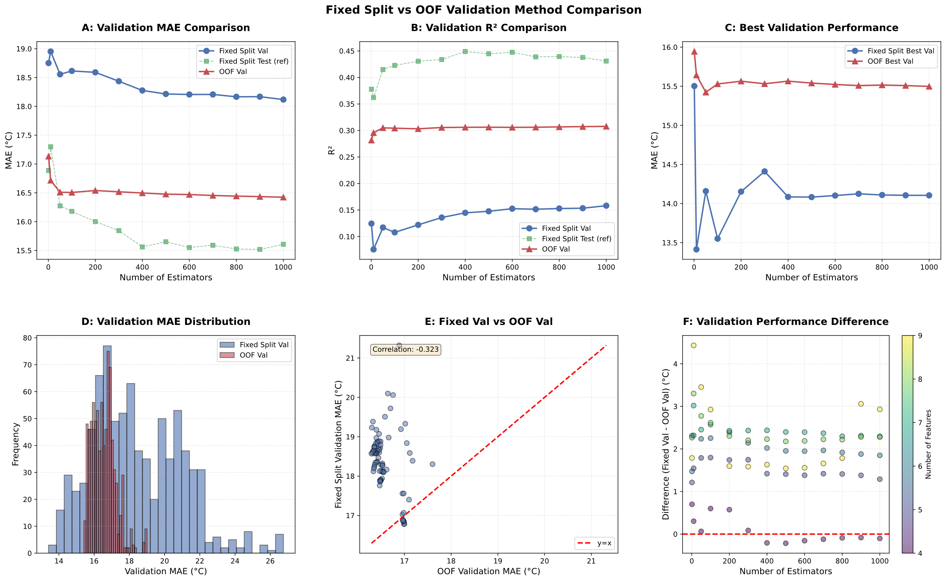
Figure 1 1. PLOT 1: Validation MAE Comparison by N_Estimators
This IS calculating AVERAGES by n_estimators!

What this means:
- n_estimators=10: Average of 63 models = 18.951°C
- n_estimators=100: Average of 63 models = 18.615°C
- n_estimators=500: Average of 63 models = 18.215°C

2. PLOT 2: Validation R² Comparison by N_Estimators
This IS calculating AVERAGES by n_estimators!

3. PLOT 3: Best Validation Performance Comparison
This shows the BEST (minimum) MAE for each n_estimators

4. PLOT 4: Validation Performance Distribution Comparison
This shows ALL individual validation MAE values (no averaging)

5. SUMMARY:
- Plots 1 & 2: Use AVERAGES by n_estimators
- Plot 3: Uses BEST values by n_estimators
- Plot 4: Uses ALL individual values (no averaging)
- The table output shows individual model values (no averaging)

6. KEY DISTINCTION:
- TABLES: Individual model performances
- PLOTS 1&2: Averaged performances for trend visualization
- PLOTS 3&4: Best performances and distributions

